

**Lab Mid Exam**

***Course Title* :** System Analysis & Design

***Course Code* :** CSE- 325

***Task Name* :**  Use Case Diagram of a Banking Management System,

Class Diagram of an Online Shopping System.

**Submitted By:**

**ID : 171442628**

**Name : Md. Akbar Ali**

**Program : CSE (Eve)**

**Batch : 44th**

**Date : 26-05-2019**

**Submitted To:**

Supta Richard Philip

Senior Lecturer, Department of CSE

City University, Bangladesh

*Use Case Diagram of a Banking Management System.*

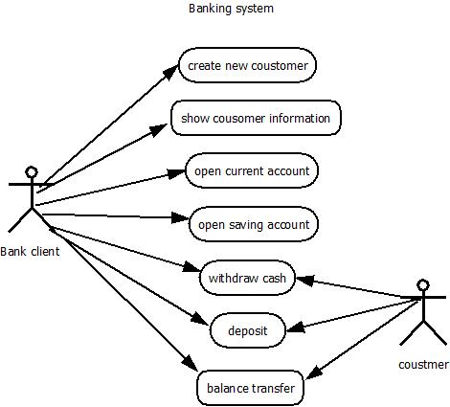

***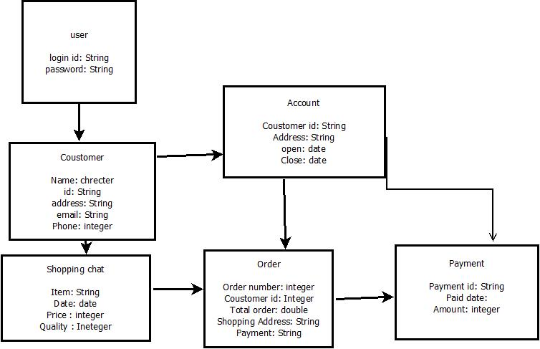****Class Diagram of an Online Shopping System.*